# TEAM GEOMANO

2223-educational-traveling project

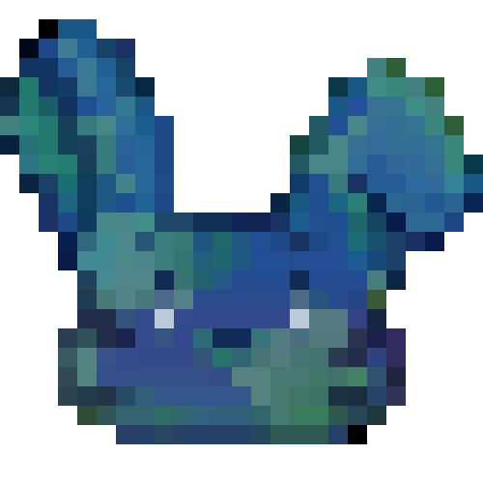

TABLE OF CONTENT

IDEA OF THE PROJECT 3

ABOUT THE GAME 3

TEAM MEMBERS 3

PROJECT DESCRIPTION 3

PERFORMED TASKS 4

USE CASE DIAGRAM 5

# IDEA OF THE PROJECT

The idea of the project is to create a game related to geography and travelling around the world using C++.

# ABOUT THE GAME

Eurobunnea is a unique game full of surprises which consists of a mix of genres. Enter the role of Star - a cute little bunny on a fun adventure around Europe. Get to face different challenges - from quizzes and mazes, to even fishes. Try on different outfits unlockable by beating levels, all while enjoying the beautiful unique style of Eurobunnea.

# TEAM MEMBERS

|  |  |
| --- | --- |
| **№** | **Roles in the team** |
| **1** | Valeria Yaneva – Scrum trainer |
| **2** | Vanesa Kardzheva – Back-end developer |
| **3** | Iliyana Michevska - Back-end developer |
| **4** | Zhanet Petkova – QA Engineer |

# PROJECT DESCRIPTION

|  |  |
| --- | --- |
| **№** | **Description** |
|  | The idea in general.  The idea is to create an adventurous game connected with travelling around the world |
| **2** | How can you access the project?  You can find our project on GitHub. You can access the files by installing the repository or pasting this to your console - https://github.com/codingburgas/2223-educational-traveling-geomano.git |
| **3** | Teamwork.  Our main communicating platform was Microsoft Teams. During the project, we met almost every day, so that everyone can catch up with the work. |
| **4** | What technologies are used?  The technologies we used are **Visual Studio Code** as our code editor, **GitHub** for collaborative work, **Microsoft Teams** for connection and communication, **PowerPoint** for creating the presentation, **Word** for creating documentation, **Test Case Lab** for the QA tests, **ClickUp** to plan and track our project and **Clip Studio Paint** for the design. |

# PERFORMED TASKS

|  |  |
| --- | --- |
| **№** | **Completed tasks** |
| **1** | Create a main page  Using the main page you can navigate through the different options of the game |
| **2** | Create Bulgaria gamemode  To win in this part of the game you should escape a maze |
| **3** | Create France gamemode  To win in this part of the game you should answer 6 out of 8 questions about France right |
| **4** | Create Italy gamemode  In this part of the game you can travel with a boat, but you should watch out for fishes |
| 5 | Create France gamemode  In this part of the game you can change the clothes of Star |
| **6** | Create QA documentation  In the QA documentation, you can find a description of steps and actions that have been taken to test the functionality of our game |
| **7** | Make the README file  In the readme file, you can get a quick overview of the project |
| **8** | Make the documentation  The documentation provides very useful information in terms of the technical aspect. You can learn pretty much everything by reading it |
| **9** | Make the presentation  We have created a short presentation to quickly show what we have done. |

# USE CASE DIAGRAM

